**SOLUTION ARCHITECTURE**

DEEP LEARNING FUNDUS IMAGE ANALYSIS FOR EARLY DETECTION OF DIABETIC RETINOPATHY

1. Binarization

2. Median filtering

3. Morphological hole filling

1. Color normalization

2. Edge enhancement

3. Color space conversion

Input Retinal Fundus Image

Pre-processing

Segmentation

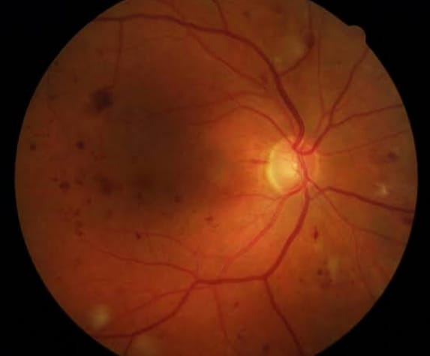

Ground truth results

Statistical validation

Feature extraction

Blood vessel detection

Blood vessel detection

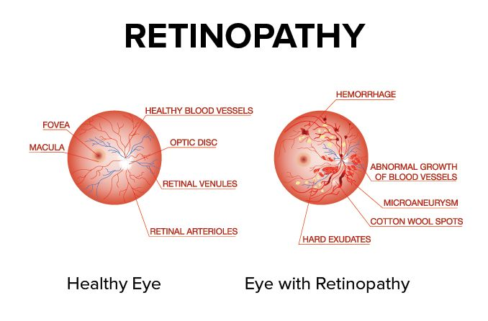 Image contain only small objects